Teodoir O’Ceallaigh

CS-330

Southern New Hampshire University

May 2022

**Project Proposal**

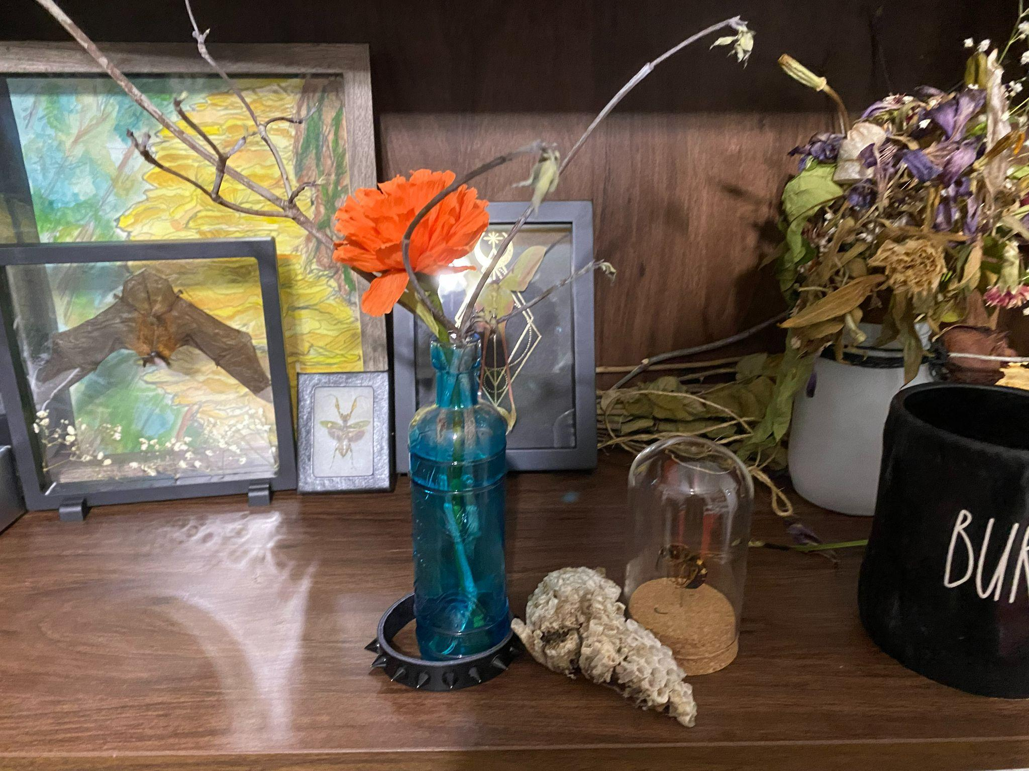

In the above photograph I will be highlighting the bottle containing the branch, the bracelet, the display dome, and the wasp nest chunk. In this scene I will be able to utilize a good portion of the primitive shapes listed, often multiple at once. I have listed below the high level plans for the shape configurations by item.

Blue Bottle w/ Branch: Multiple cylinders and torus to help round out the top portions of the bottle.

Bracelet: A torus and multiple cones.

Wasp nest: Pyramids both normal and inverted (subtraction).

Display Dome: Cylinder, sphere, and perhaps a torus as well.

These objects will be great practice for rendering 2D objects in 3D because they contain a multitude of primitive shapes for practice while also being items that I am emotionally invested in recreating for fun. I am very excited to begin working on this project andhope to provide as much detail and do the image justice.